Group Member:

1. Muhammad Luqman Bin Mohd Azman B031910487
2. Badrul Amin Bin Ismail Nasarudin B031910475 (Project Manager)
3. Syed Muhammad Harith Al-Gadri Bin Syed Abdul Rahman B031910496

Title: BSDT (Blind Spot Detection & Tracker)

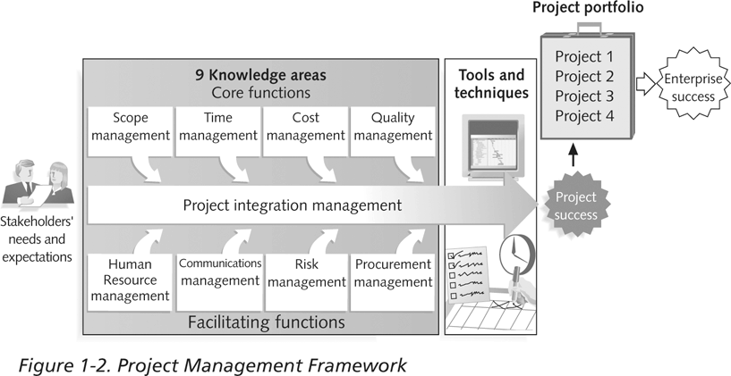

Scope Management:

Since there’s many motorcycle accidents occurred in Malaysia. We suggest building BSDT. BSDT will be using AI to classify vehicles from the camera and then the system will give indicators to users that they are in the blind spot of another vehicle by using LiDAR. We will be preparing the scope statement and we will be using a work breakdown structure to manage the project.

Human Resource Management:

To make this project successful, we have to be emphatic listening to brainstorm an idea. To complete the project before the due date, we will be using motivation exercise and team-building exercise to motivated everyone in the team to work on the project.

Risk management:

To identify and manage the risk of the project, we have to create a risk management plan to minimize the risk. To identify the risk, we also will be using probability/risk matrices. By using risk ranking, we will be able to identify which risk is more important to be minimalized.

Cost Management  
To ensure our project did not exceed the budget given by the client, we need a cost management plan to control our cost. We will use project portfolio management, cost estimation and cost baseline to identify which things are more important to spend on.

Quality Management  
To ensure our project comply with the client request, we will use the quality metrics as our indicator to our project. We will also use checklists, fishbone diagrams and statistical methods to measure our project quality.

Procurement Management

As for the procurement management, we will use contract, request for proposals or quotes, and source selection to make sure our project will be able to progress at the right time and also able to be delivered to the client as intended.

Time management

One of the biggest challenges for project managers is to complete projects on time. To make sure that the project will be completed on time, we will be using gantt chart and project diagram to make sure that the project will be completed before the deadline

Communication management

Project communication that is poor leads to projects failure. To manage and make sure that we have good communication management, we use kick-off meetings, status and progress reports and also virtual communication. This tool will help us communicate better in order to complete the project